SOFTWARE ENGINEERING PROJECT
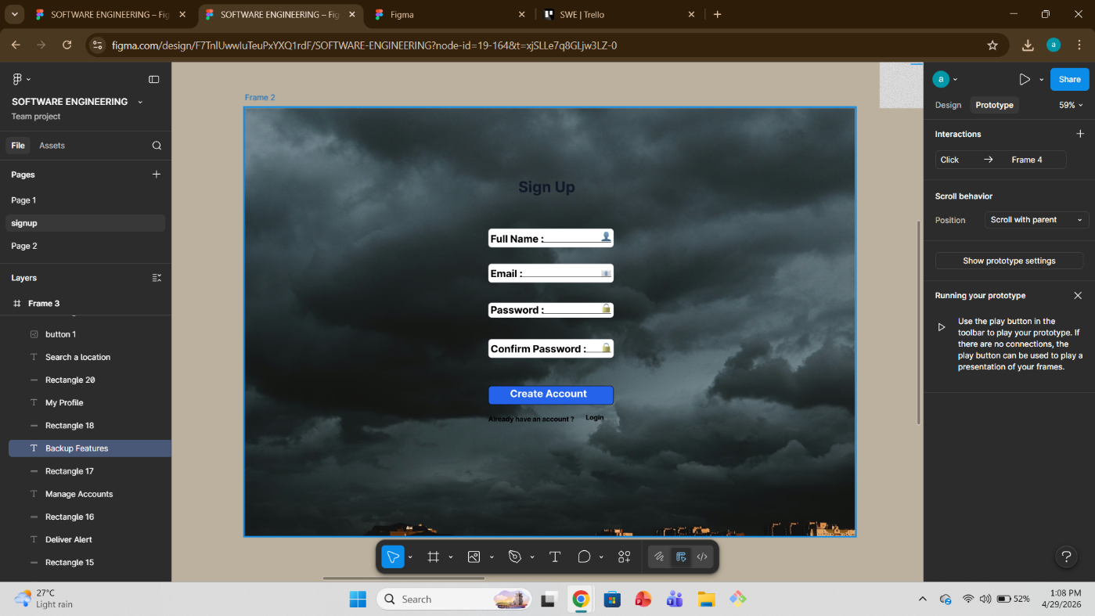
Figma Design 1 : Sign Up Page.
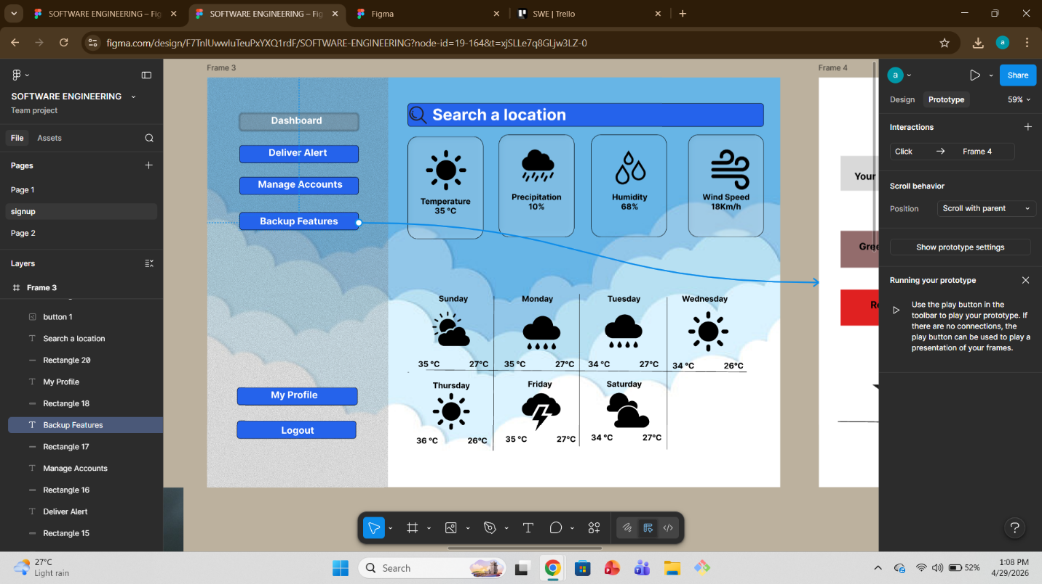
Figma Design 2 : Dashboard
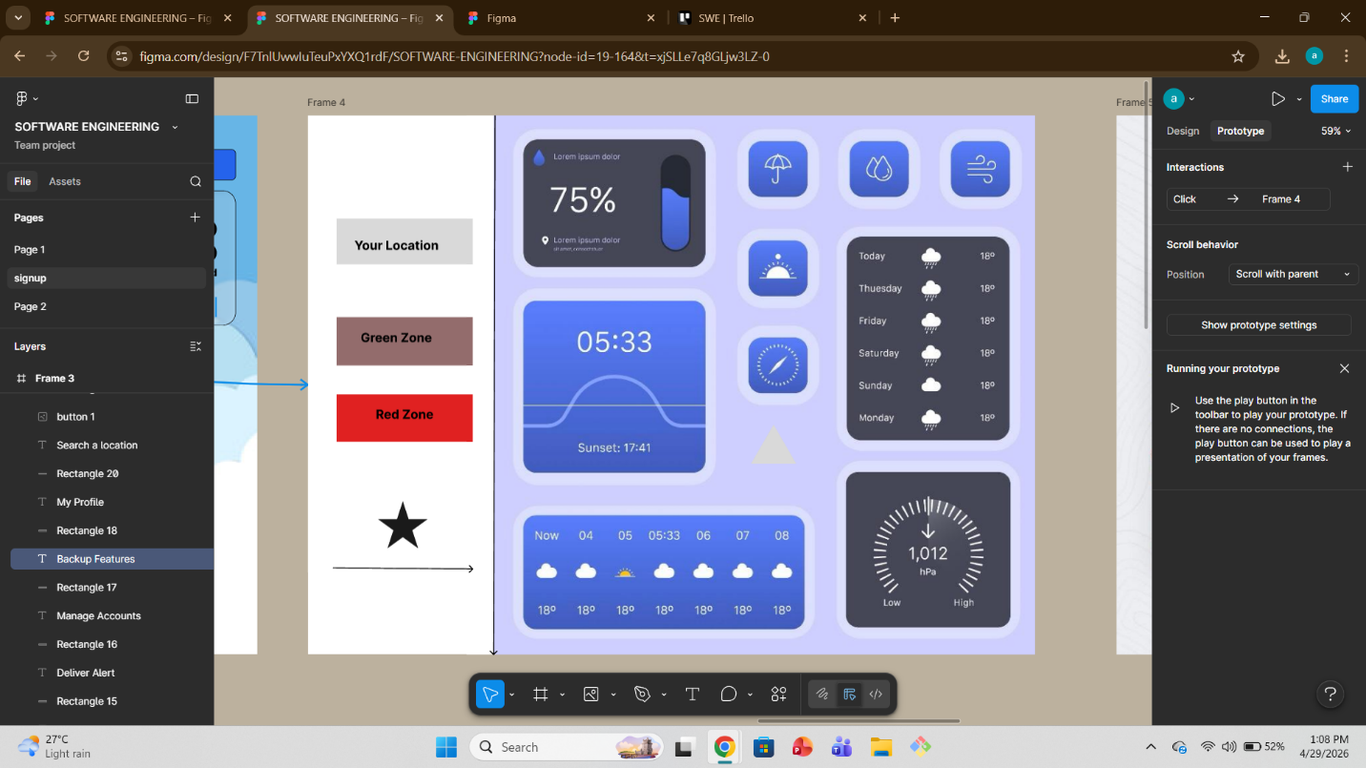
Figma Design 3: Route Finding
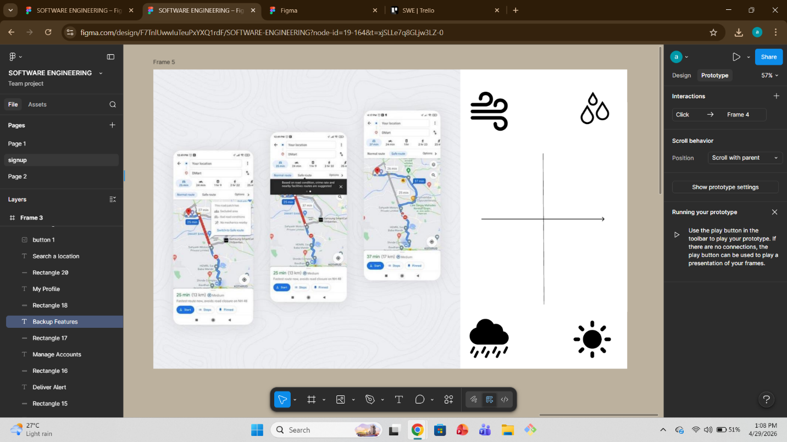
Figma design 4 : Search location.
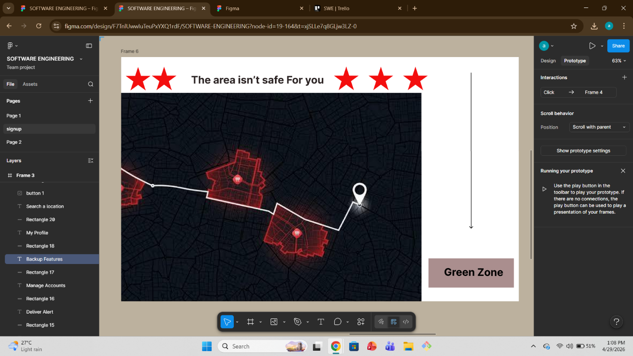
Figma Design 5 : Showing Red Zone
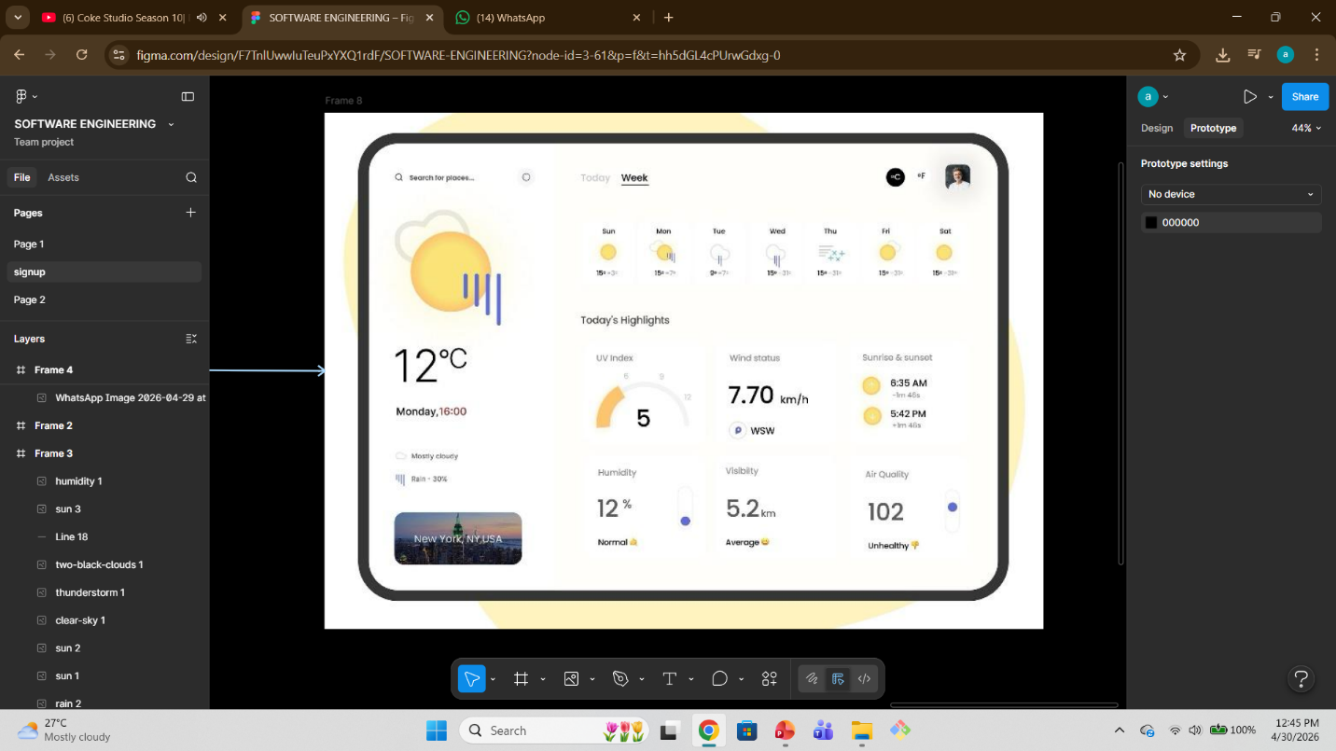
Figma Design 6 : My Profile
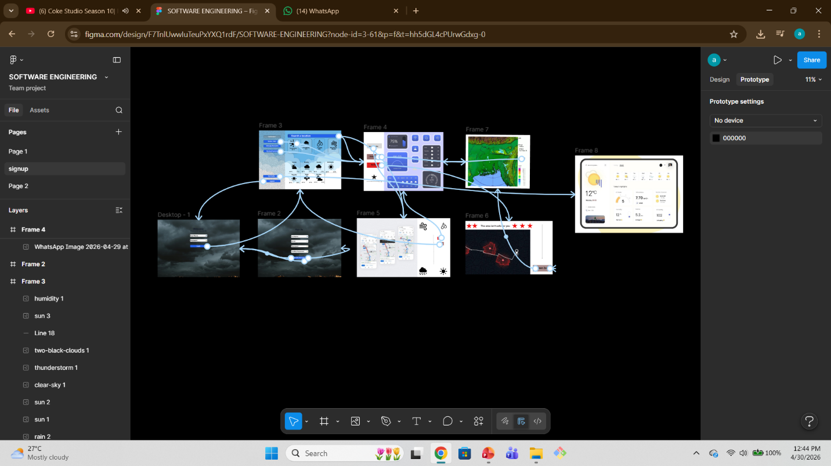
Figma Design : All Prototype Together
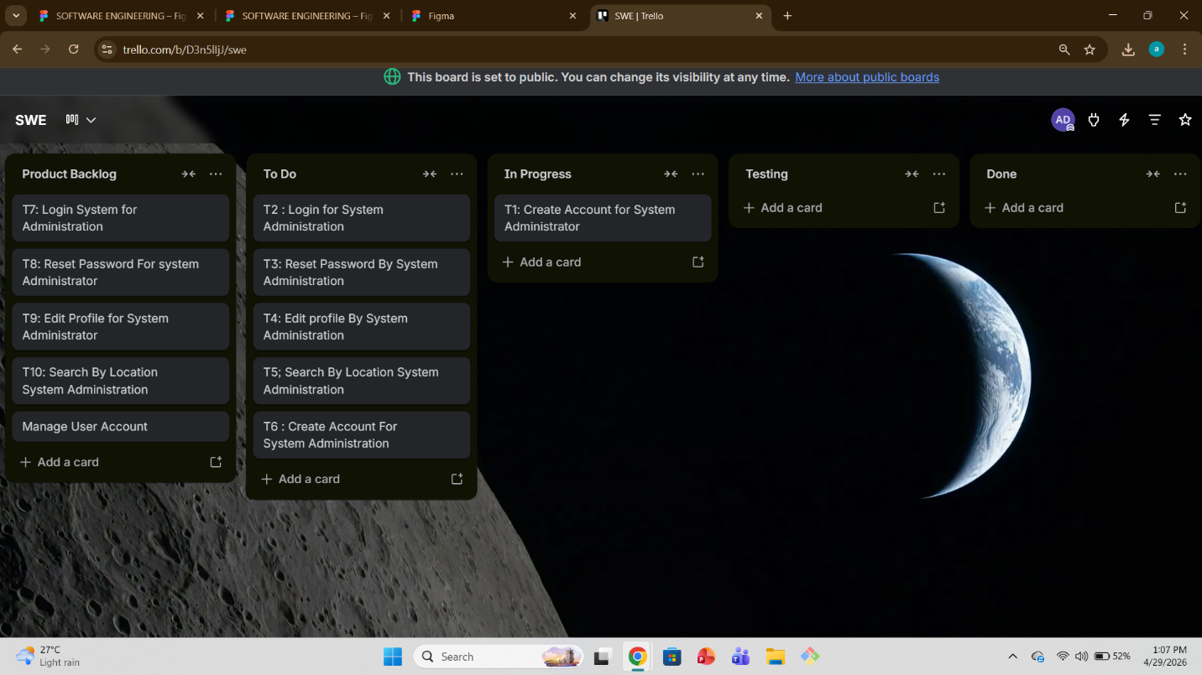
Trello : Working Schedule..

